EGR2312 Lab Experiment N°9

SHEARING AND BENDING MOMENT DIAGRAMS
- Introduction :
In this experiment, we will work on drawing the shear and bending diagram of a beam. Using the machine in Figure 1, we will measure the shear force and bending moment of a beam after subjecting it to given loads. Then, we will compare the experimental values to the theoretical ones.
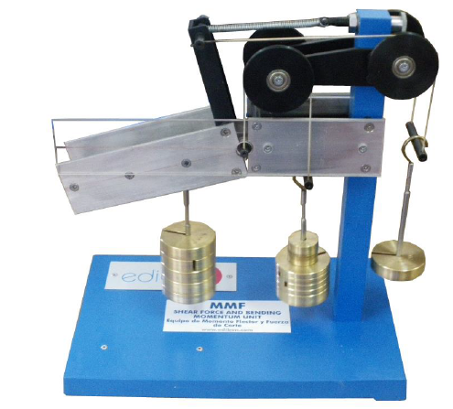
Figure 1. Shearing force and bending moment device
- Theory :
The shearing force is defined as the algebraic sum of the transverse components of the forces to one side of the section. The bending moment is defined as the algebraic sum of the moments of the forces at one side of the section.
The shear force and bending moment machine allows you to insert a force at different points as seen in figure 2, allowing us to observe the behavior of the beam at different locations.
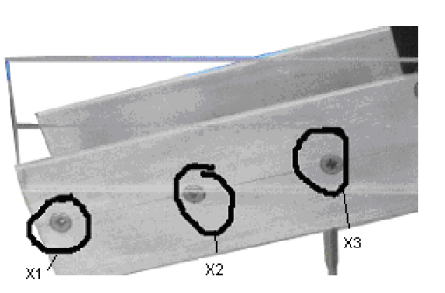
Figure 2. different points

- How to proceed

Figure 4. offers a description of the device that you will use for this exercise.
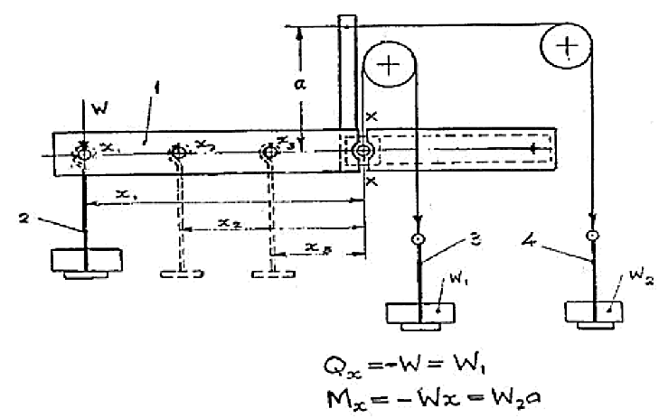
4
3
2
1
Figure 4. Description of the device
1 is the beam
2 is the load hanger
3 is the shear force load hanger
4 is the bending moment load hanger
where:
X₁ = 0.15m
X₂ = 0.10m
X₃ = 0.05m
a = 0.105m
Step 1: Without there being any load applied to the beam, check that the beam is in its equilibrium position. Adjust the tension springs if necessary. Its equilibrium position is that in which the mark on the transparent screen coincides with the straight mark on the beam.
Step 2: Attach the load hanger (2) and weights to the beam at position X₁ and add weights to the hangers (3) and (4) until the beam returns to its equilibrium position.
Step 3: Repeat the experiment with the same load for at position X₂ then X₃, balancing hangers (3) and (4) with weights.
Step 4: Repeat the two previous steps, this time applying a higher load with the load support (2).
Record the values for each position of the load W and compute the shear force Q and bending diagram M using:
Shear force:
Q = W₁ = load x g
Bending moment:
M = W₂·a = load x g x a
- Preparing your lab report
- Below is the free body diagram of your beam, with a load applied at X₂. How would you compute the shear force and bending moment in this case?

Figure 5. Free body diagram, load applied at X₂

Application Point (m) | Load applied (g) | Mass (g) in Shear force load hanger | Shear force, W₁ | Mass (g) in Bending Moment load hanger | W₂ (g) | Bending moment M
X1 = 0.15
X2 = 0.1
X3 = 0.05
X1 = 0.15
X2 = 0.1
X3 = 0.05

Table 1. Data collection
- Draw the shearing force and bending moment diagrams for the two applied loads (insert 4 plots, 2 for each applied load).
- Compare your experimental values with the theoretical ones. Show your computations. Report your results in the table below:
Application Point (m) | Experimental shear force | Theoretical shear force | % error | Experimental bending moment | Theoretical bending moment | % error
X1 = 0.05
X2 = 0.1
X3 = 0.15
X1 = 0.05
X2 = 0.1
X3 = 0.15
Table 2. Experimental VS Theoretical Results
- What affects the value of the shear force? When will the shear force be maximum in our case?
- In the case of this beam, where should you locate your applied load to obtain the maximum bending moment?

